Paper Title: Instructions and guidelines to authors

Surname Name ¹, Surname Name ²

¹ Affiliation: Institution Name, address, Postal Code - City, Country

² Affiliation: Institution Name, address, Postal Code - City, Country
corresponding author: name, surname, postal address, telephone and fax numbers, e-mail address
Keywords: xx, yy, zz

Abstract
Insert your paper abstract for a maximum of 25 lines.
1. GENERAL DATA
As the proper completion of the event, the Organizing Committee will collect in Proceedings and Guidelines EXTENDED PAPERS of your abstracts. Manuscripts should be submitted by e-mail to the following address: ecsac@ictp.it and in c.c. (carbon copy) to dellaved@units.it. If specific information are required, please contact first address and request for a skype or phone communication.
The dead line for submission will be Friday 31st October.
Manuscripts should conform to the present guidelines. They should be 4-10 pages including occupied spaces for titles, references, figures and tables (exceptions may be agreed with the Organizing Committee).
Manuscripts submitted should not have been previously published or simultaneously submitted to other journals. Manuscripts should have an original content or involve major extensions, innovations or revisions of already published papers. After submission, correction of proofs should be preferably limited to printing or typesetting errors. If manuscripts will be delivered to referees, they will keep them absolutely confidential and may opt to remain anonymous.
Publication of the manuscript will be solely managed by Conference Organizing Committee.

2. SPECIFIC INSTRUCTIONS
Multi-Author manuscripts should carry the name of the corresponding author (name, surname, postal address, telephone and fax numbers, e-mail address). Any communication or decision made by the Corresponding Author will be supposed to represent the opinion of all other Authors.
In the proper section, please insert from a minimum of 3 up to a maximum of 7 keywords.
The text heading cannot exceed one line and should be type in Times New Roman, 9 pts, bold, justified text, single spacing, 0 cm indentation from left margin. Headings must be numbered and formatted as this document title 1 style.
Manuscripts text should be typed in English with Microsoft Word for PC or Mac with the following format: Times New Roman, 9 pts, justified text, single spacing, 0 cm indentation from left margin, without hyphens at the end of the line. Each page should be numbered.
Figures, equations, and tables have to be included with the best possible quality; in Word please do not use “copy and paste” sequence but insert figures and tables from upper menu bar (Insert → Image or Table). Captions to figures, tables or plates should be embedded into the text, in the place where the figure, table or plate is to be inserted and should be formatted following the given examples. All illustrations should be cited in the text as Figure 1, Table 1, Plate 1, etc. Parts of figures should be indicated as Figure 3a, etc.
All maps, field drawings and photos should have a metric scale bar and, where necessary, longitude and latitude. Maps and drawings should only include toponyms, units of measurement, acronyms and numbers, so that each figure may be extracted or quoted in other texts in a language different from the original one. Figure captions should include a legend explaining the symbols, acronyms and numbers used in the figure.
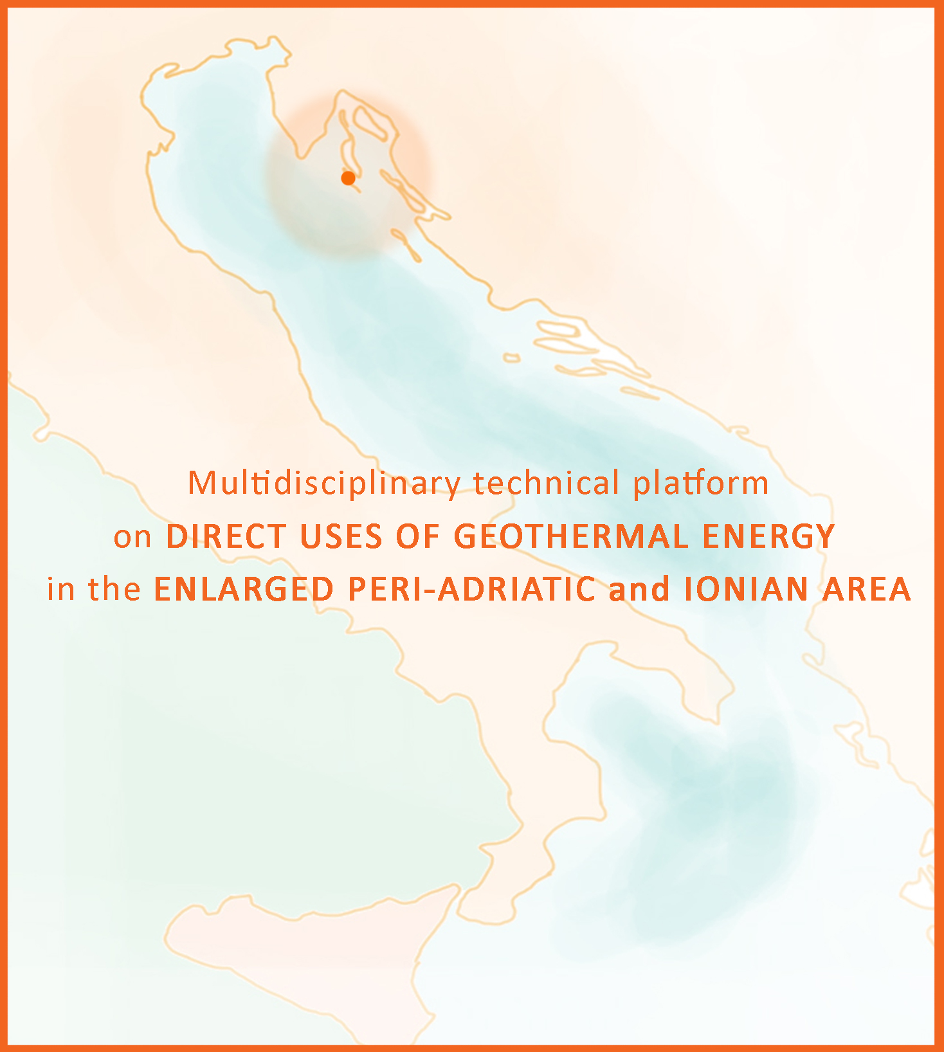
Figure 1. Enter the figure caption with this style.
Use of footnotes in the text should be kept to a minimum. Footnotes will be numbered consecutively and automatically by Microsoft Word. For the content of footnotes, use should be made of the Normal style. Some parts that are not essential for understanding the text (lists of data, special descriptions, etc.) may be typed with single spacing.
References quoted in the text should be put between parentheses: name of the Author in capitals, comma, year of publication. Multiple References consecutively quoted should be put in chronological order and separated by a semi-colon (e.g. RAMSAY & HUBER, 1987; HOBBS et alii, 1990). Papers in preparation or review and oral communications may be quoted in the text but not in the References.

3. EXAMPLE OF list paragraph FORMAT
If you need to list paragraph us this style:
- list paragraph 1;
- list paragraph 2;
- last list paragraph.
The main text may be divided into three hierarchical levels:
- list paragraph A
  - list paragraph B
    - list paragraph C

4. INSTRUCTIONS FOR acronymS AND MEASURES
In the text, long and recurrent phrases may be used in the expanded form the first time, followed by the acronym between parentheses; the acronym will be used in all subsequent recurrences of the phrases (e.g. consolidated undrained test: CU test). Too many acronyms within the same article are not recommended.
Cardinal points should be quoted in the expanded form in small letters (e.g. to the north, to the west-south-west of Rome). However, they should be abbreviated when they represent directions (e.g. WSW-ENE, NE-SW).
Measurements should be given in SI (International System of Units) metric units, using standard symbols (km, m, mm, kPa) in small letters and not followed by a period; exponents, too, should conform to the SI (exponent written as a superscript, e.g. m3 and not cu. m.).

5. HOW TO FORMAT REFERENCES
The list of references, in alphabetical order, should be headed "References" and formatted as the specific references suggested as example. The list should include all and only the References cited in the text. Papers that have been accepted for publication and that are actually in press may be cited, specifying the name and the volume of the journal or the degree or Ph.D. thesis.
References should be arranged alphabetically by author's surname. For references with two authors, list alphabetically by first author's surname and then alphabetically by second author's surname and so on. Multiple papers by the same author published in the same year should be specified with small letters after the date (e.g. a, b, …).
Authors must be quoted with their surname (first letter in capital), followed by their dotted initials; names of multiple authors should be separated by commas. After the title, the name of the journal should be specified with the usual abbreviations and followed by the volume number (Arabic numeral), by the issue number, the page numbers from the initial to the last one (using 3 digits only, e.g. 457-632). All these numbers should be separated by commas and terminate with a period.

References
Banerjee B., Das Gupta S.P.: Gravitational attraction of a rectangular parallelepiped, Geophysics, vol. 42, n° 5, (1977), 1053-1055.
Calore C., Della Vedova B., Grassi S., Marson I., Nicolich R., Squarci P.: A hydrotermal system along the Coastal Area of Friuli-Venezia Giulia Region (NE Italy), Proceedings of the World Geothermal Congress, Florence, n° 2, (1995), 1269-1274.
Cassano E., Anelli L., Fichera R., Capelli V.: Pianura Padana. Interpretazione integrata di dati geofisici e geologici, 73° Congr. Soc. Geol. It, (1986).
Cati A., Sartorio D., Venturini S.: Carbonate platforms in the subsurface of the Northern Adriatic Area, Mem. Soc. Geol. It., vol. 40, (1987), 295-308.
Eberhart-Philips, D., Stanley, W. D., Rodriguez, B. D. and Lutter, W. J.: Surface seismic and electrical methods to detect fluids related to faulting, Journal of Geophysical Research, 100, no. B7, (1995), 12919−12936.

Acknowledgements
This space is for thank institution for field support, data acquisition and processing, permission to present the paper, fruitful discussion and so on.

